Application load balancer
- Create EC2 Instances
Launch at least two EC2 instances with web server software installed (e.g., Apache, Nginx)

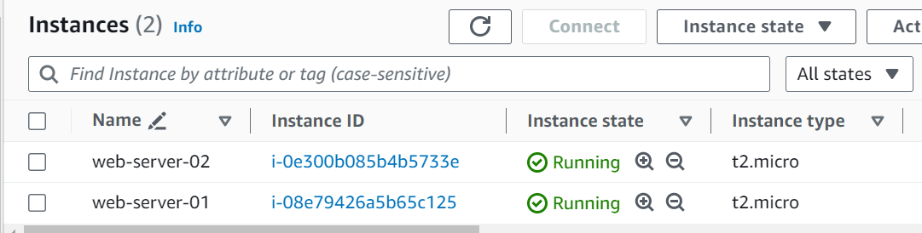

Ensure they belong to the same security group allowing traffic on the web server’s port (e.g., port 80 for HTTP).

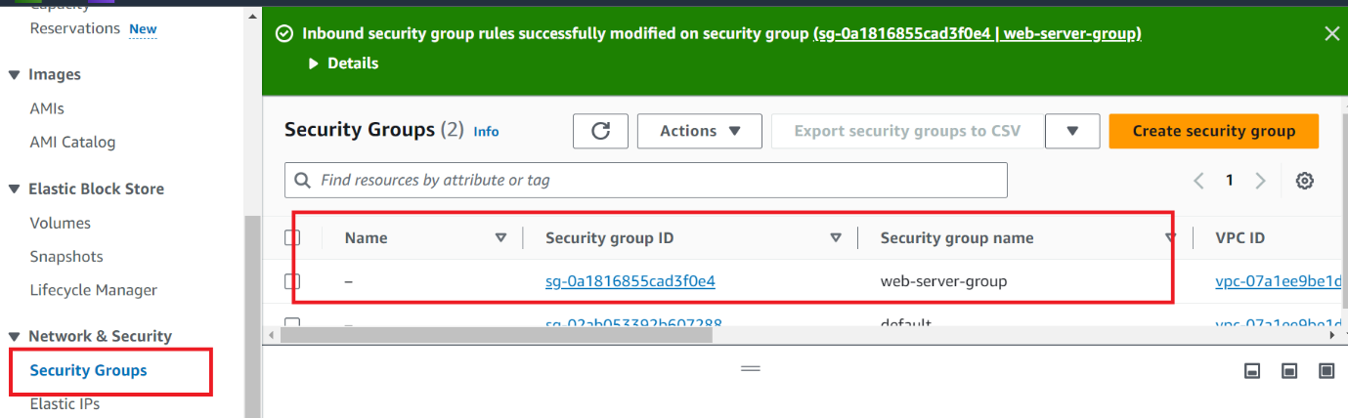

Check Inbound Rules
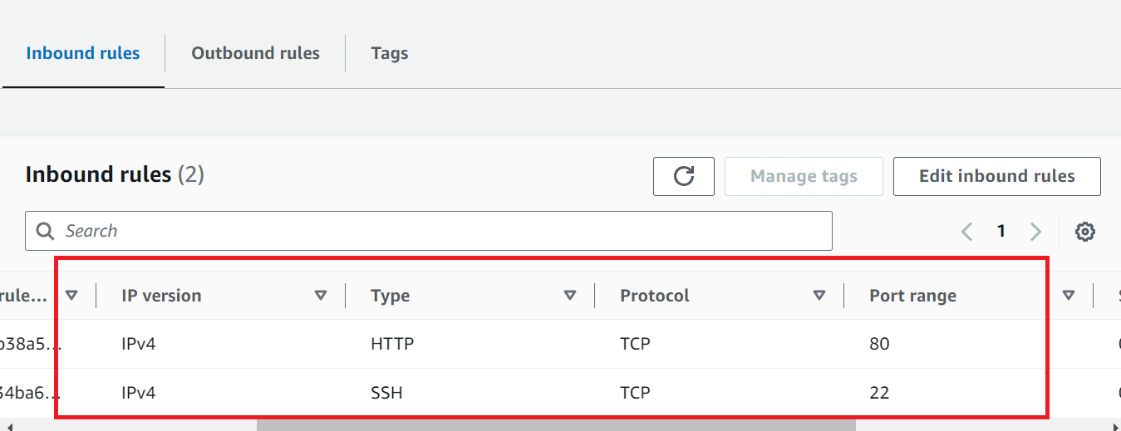

Create a Target Group
- In the AWS Management Console, navigate to the EC2 service.
- Create a target group, specifying the target type (e.g., instances) and the protocol and port (e.g., HTTP on port 80).
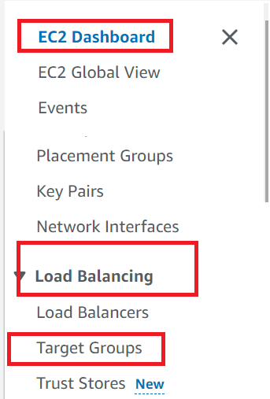
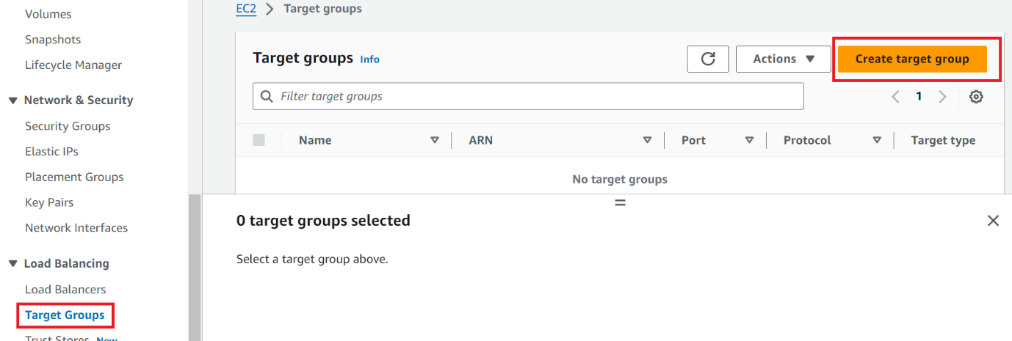

Provide Target group name
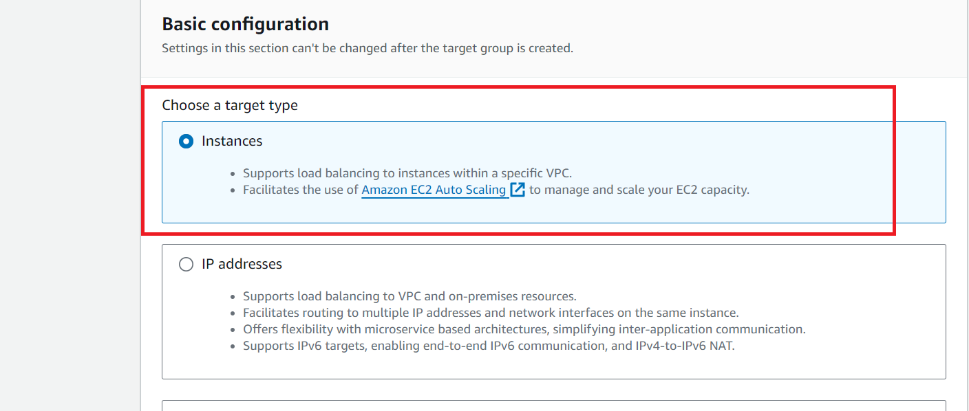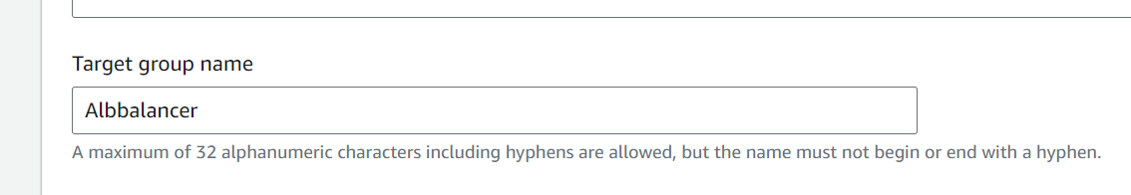

Select VPC

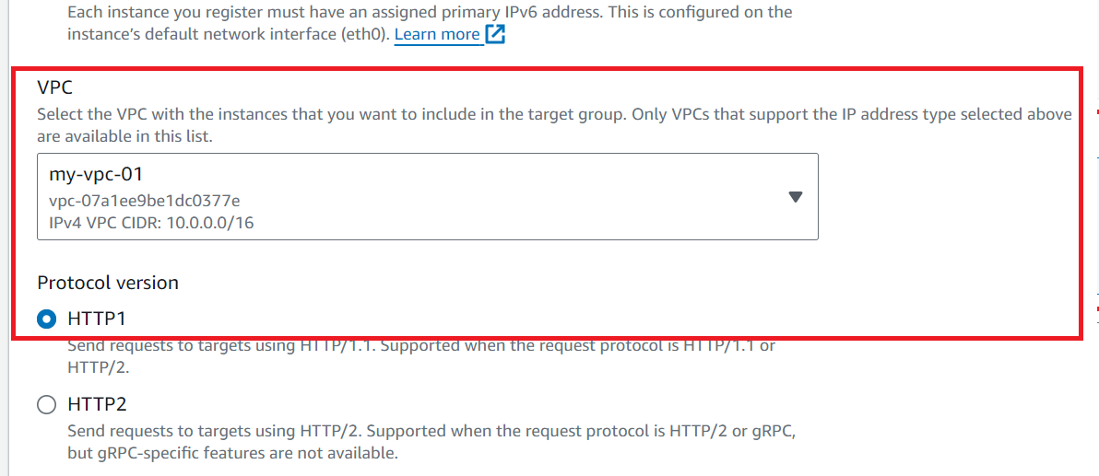

Press next
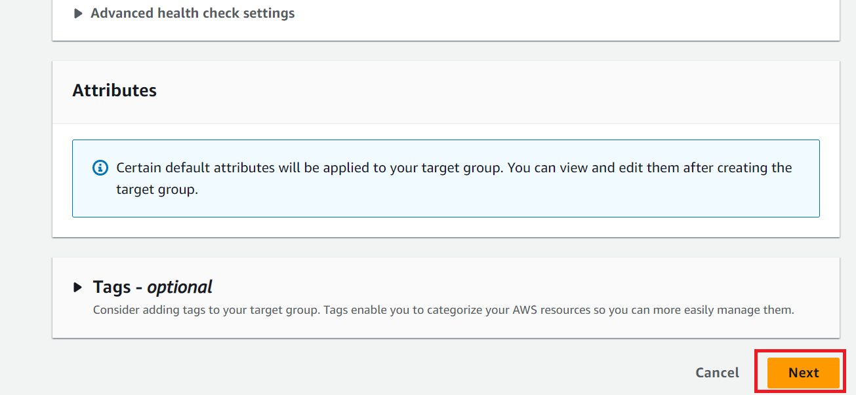

Create Target Group
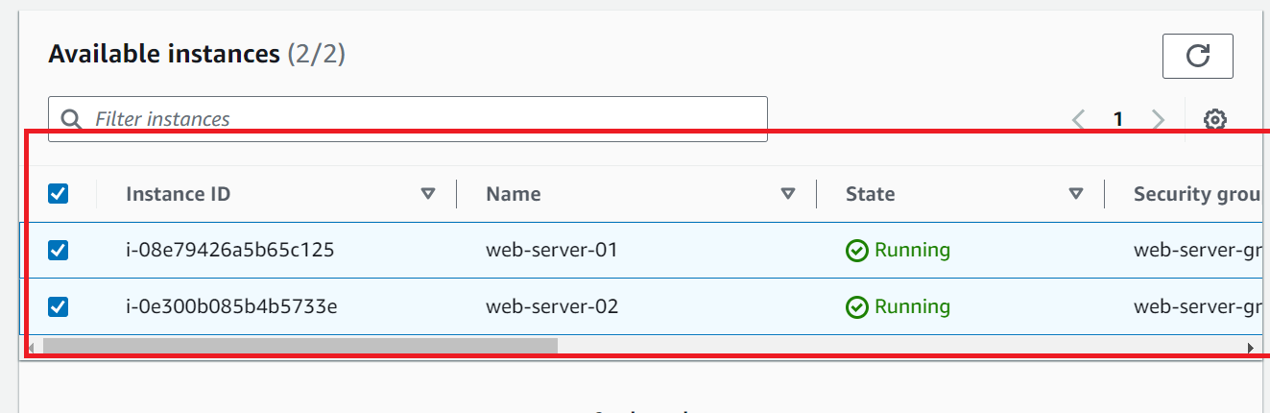

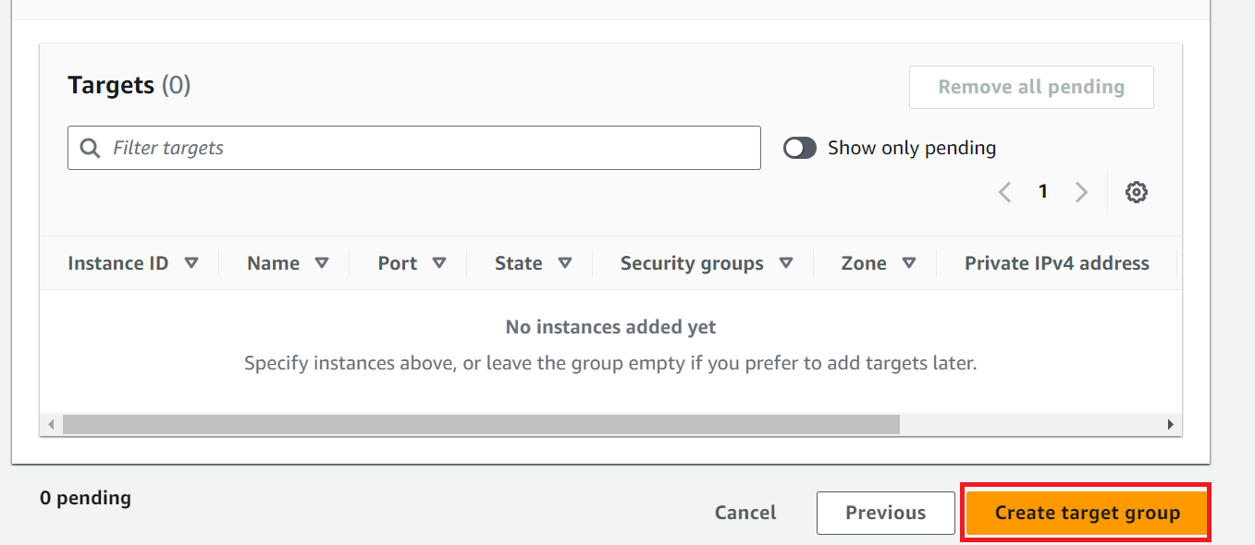

Register EC2 Instances
Register the EC2 instances you created in the target group.
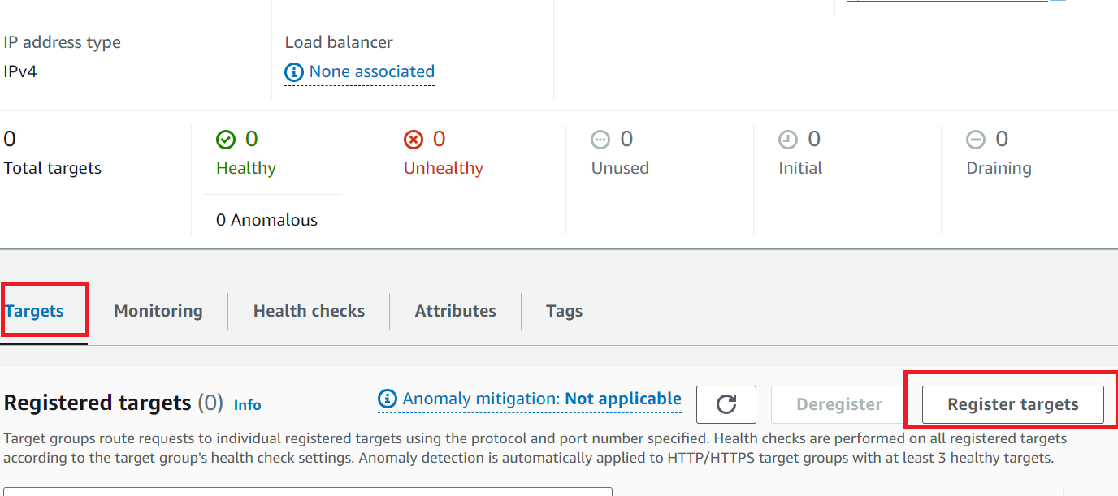
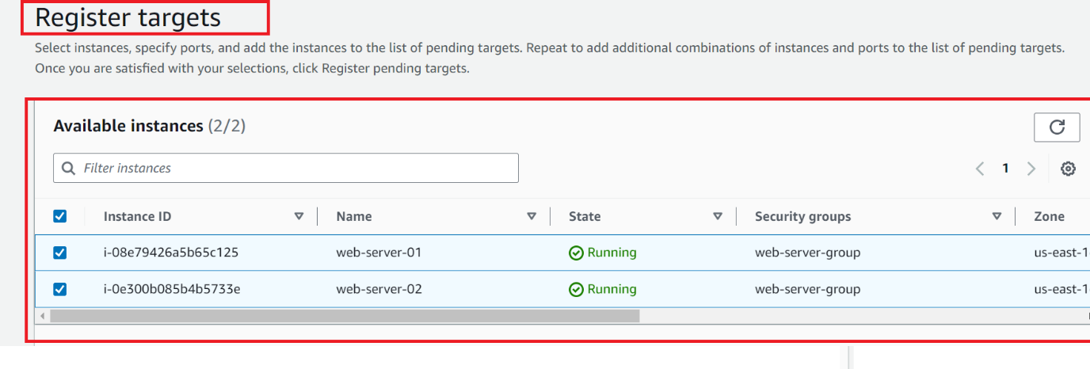
Create an Application Load Balancer
- In the AWS Management Console, navigate to the EC2 service.
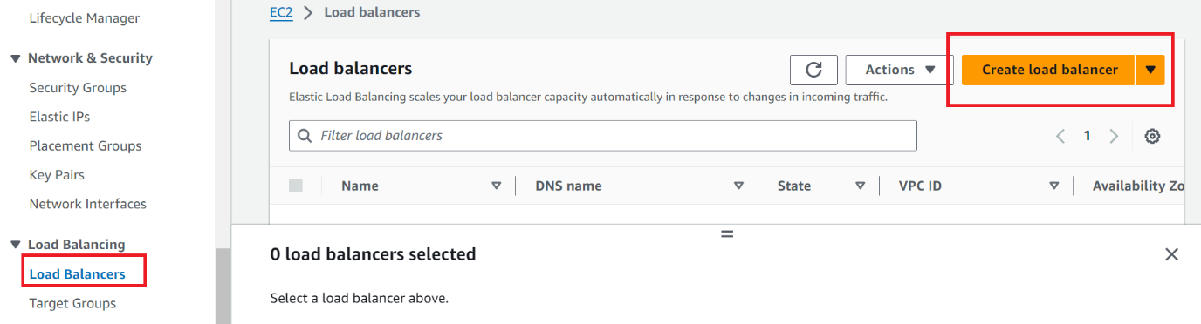
Create an Application Load Balancer (ALB) and configure listeners (e.g., HTTP on port 80).

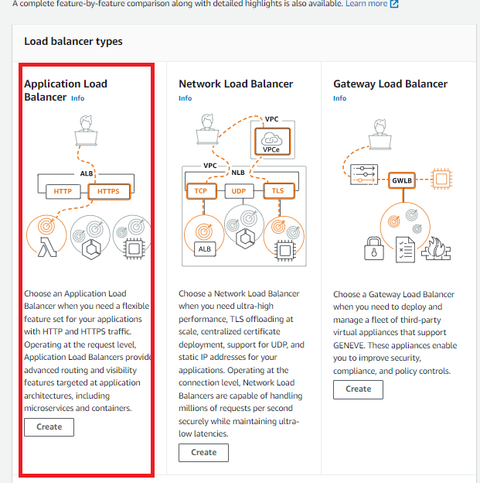
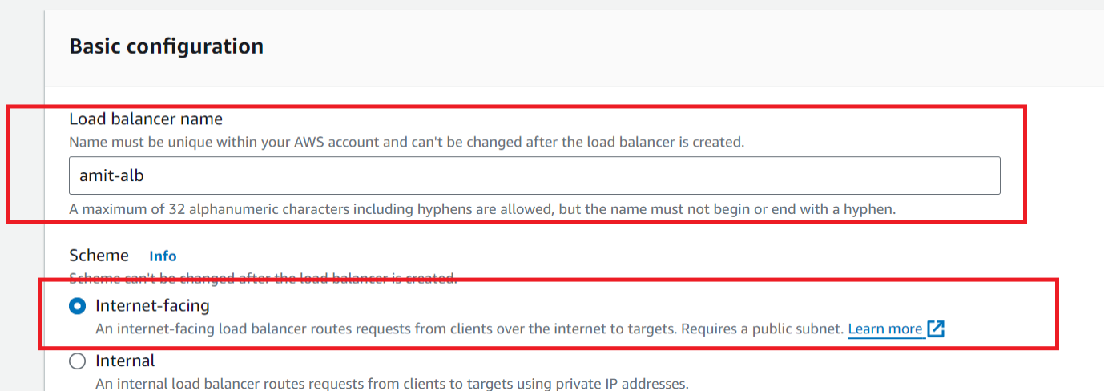

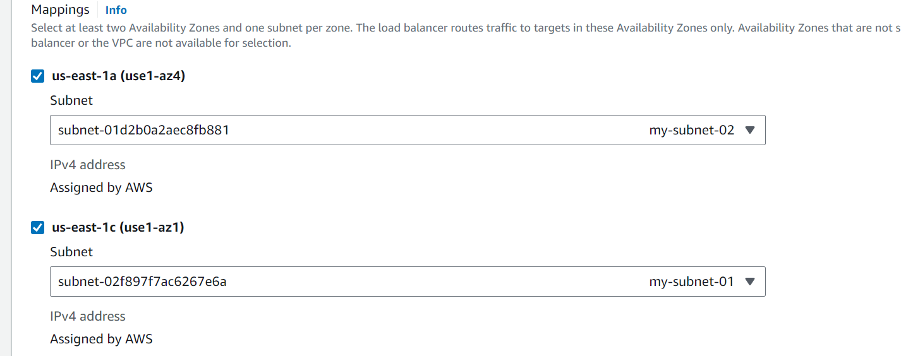
Select security group, which ec2 is using
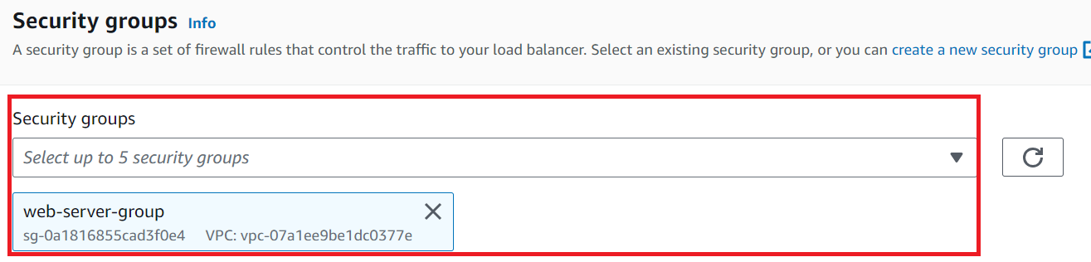

Listeners and routing
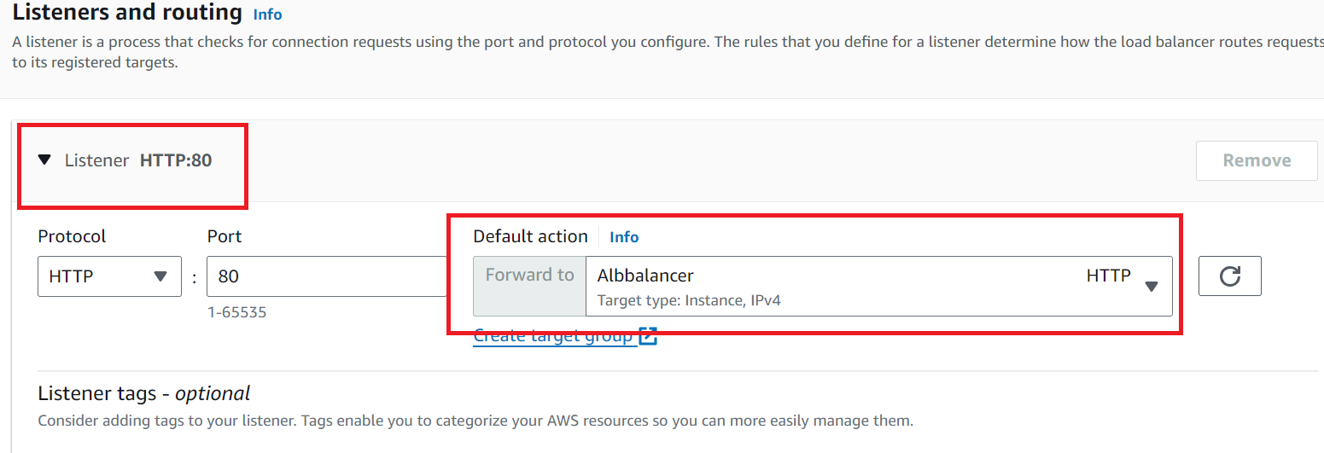

Create load balancer
